|  |
| --- |
|  |
| AWS Face detection Screenshots |
|  |
|  |
| **NAME: Akhil Shetti** |
|  |

|  |
| --- |
|  |

**Email ID:** [**shettiakhil@gmail.com**](mailto:shettiakhil@gmail.com)

**State: Maharashtra**

**College: Datta Meghe College Of Engineering**

**Category: Electronics (Final year)**

1. **AWS dashboards:**
2. **login screen user name:**

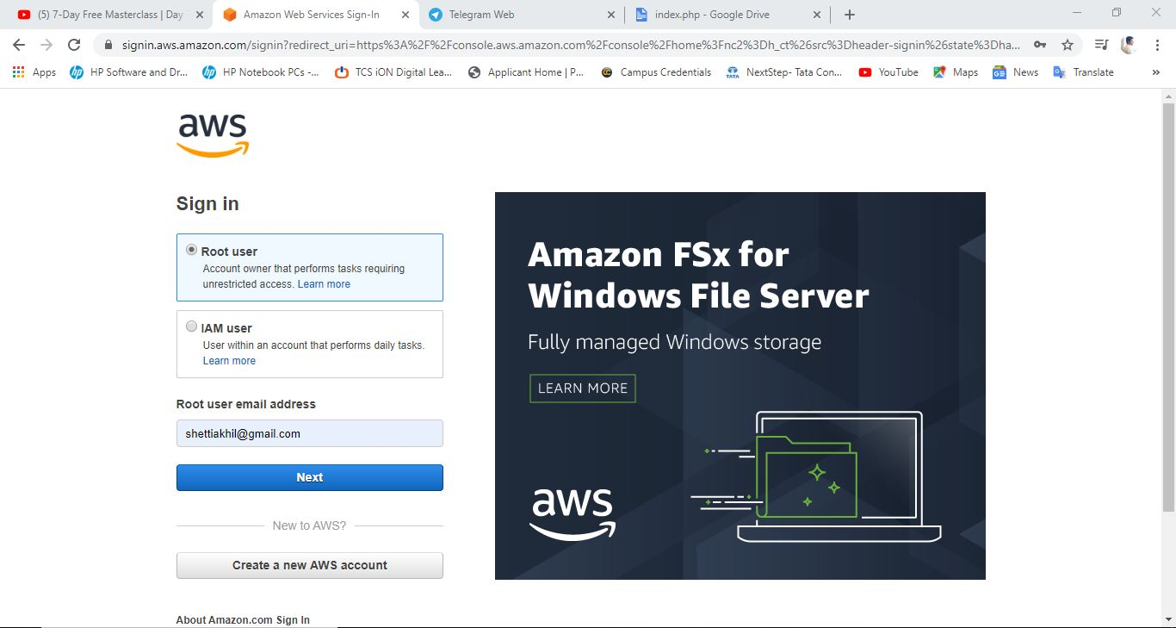

1. **ec2 dashboard:**

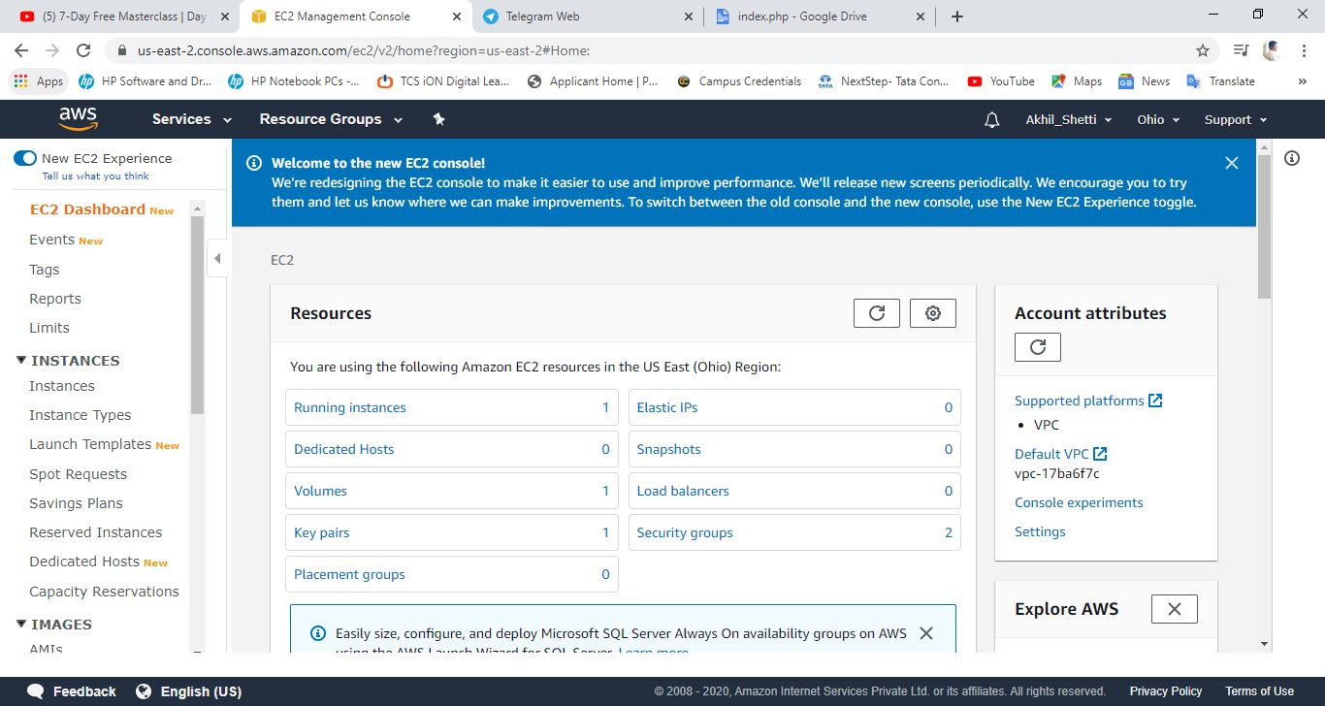

1. **s3 dashboard:**

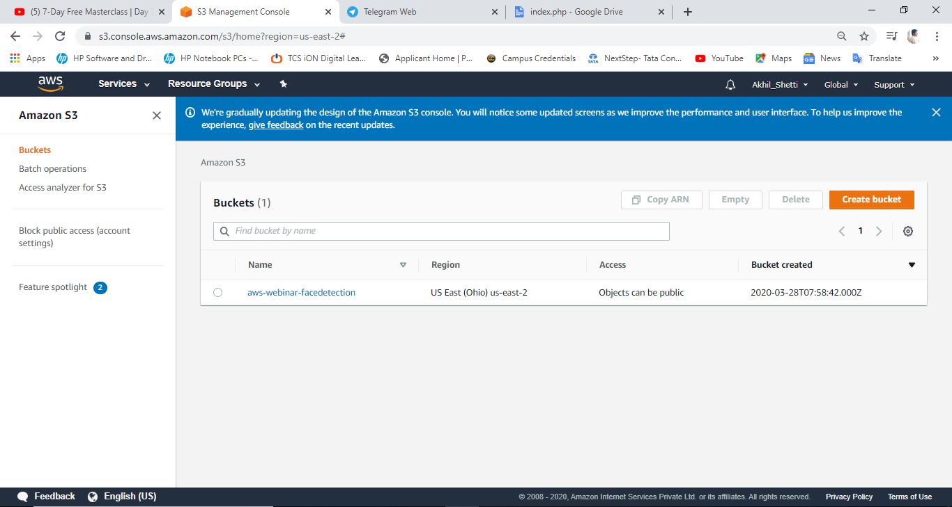

1. **rekognition dashboard:**

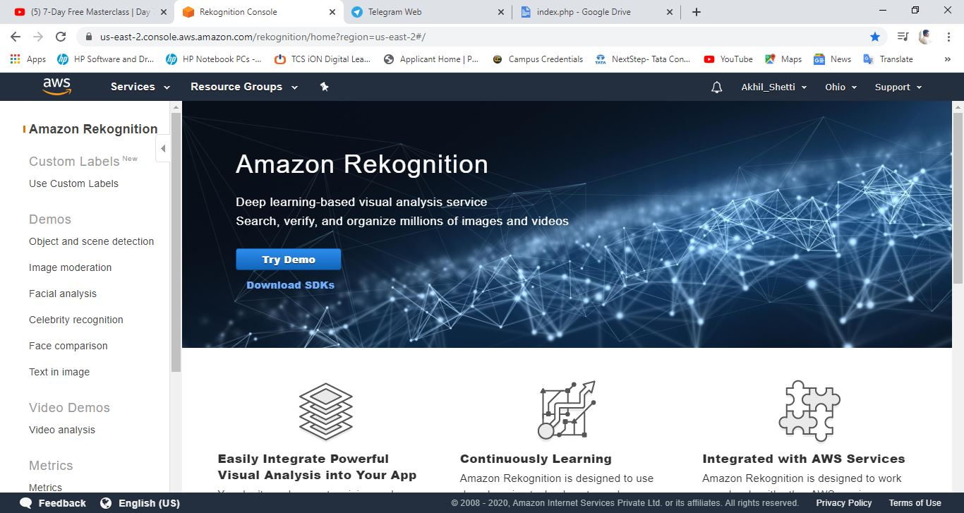

1. **EC2:**
2. **Choosing AMI:**

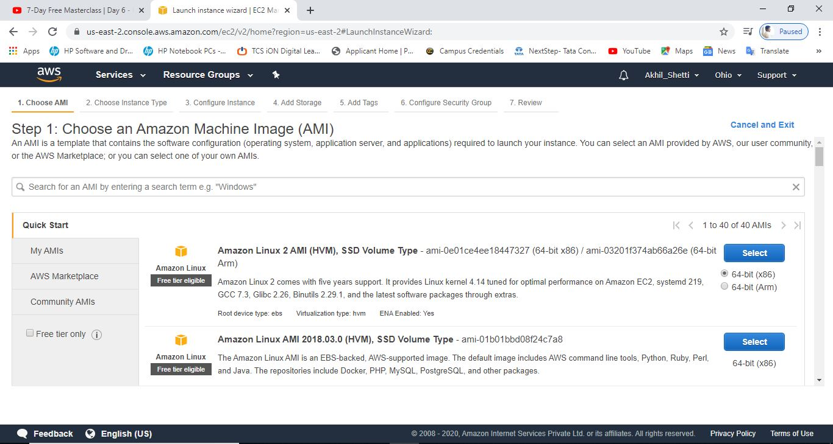

1. **Choosing Instance type:**

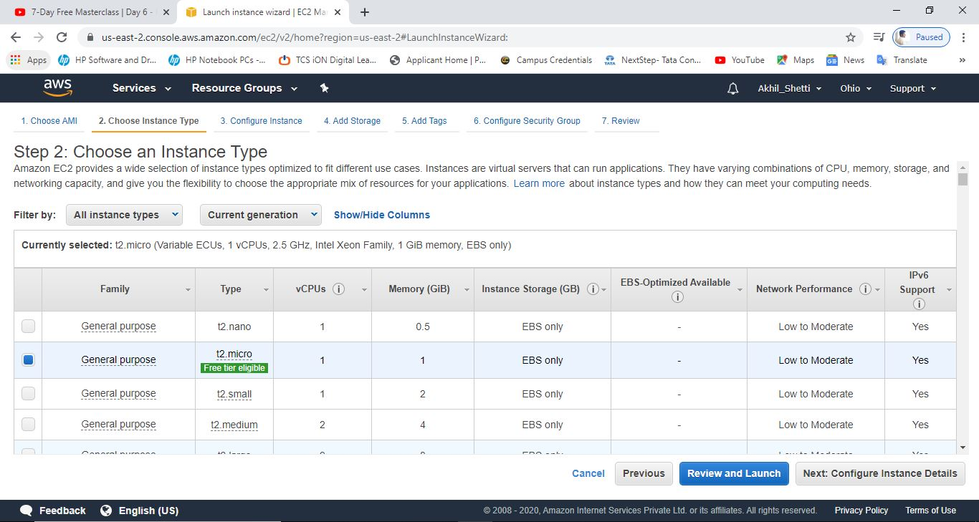

1. **Configure Instance:**

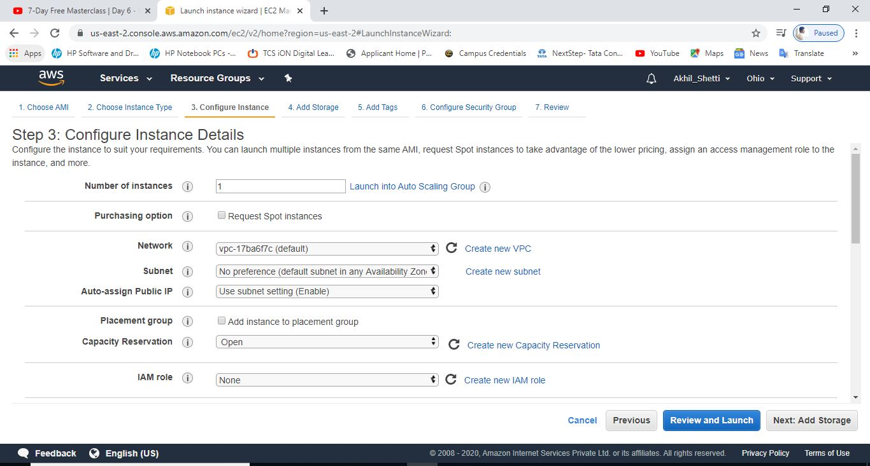

1. **Adding storage:**

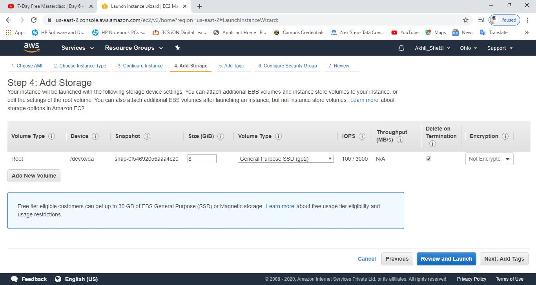

1. **Add tags:**

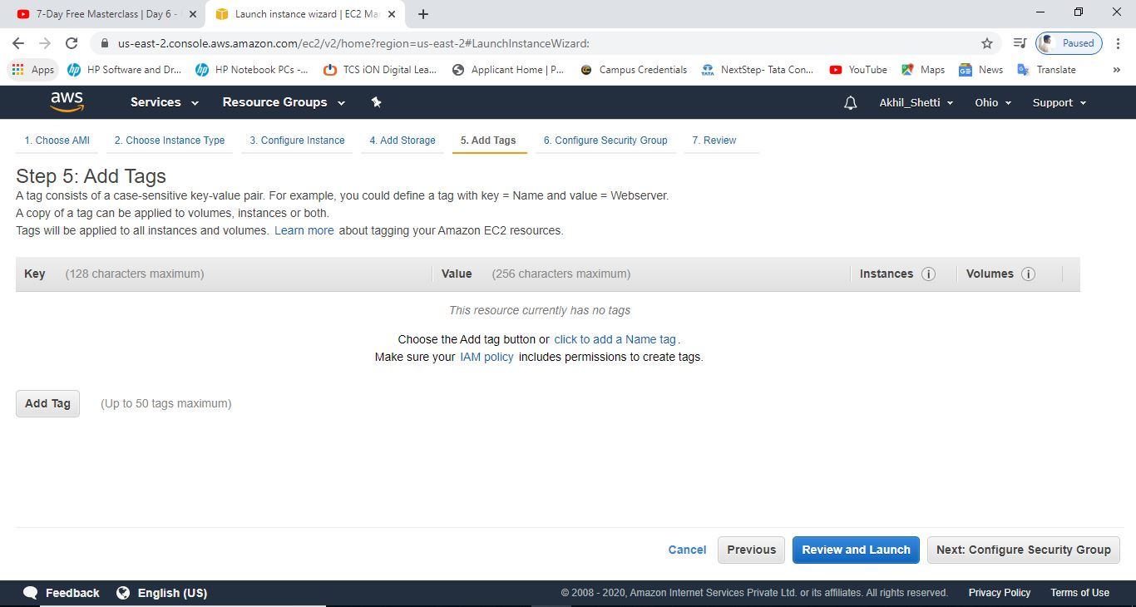

1. **Configure Security groups:**

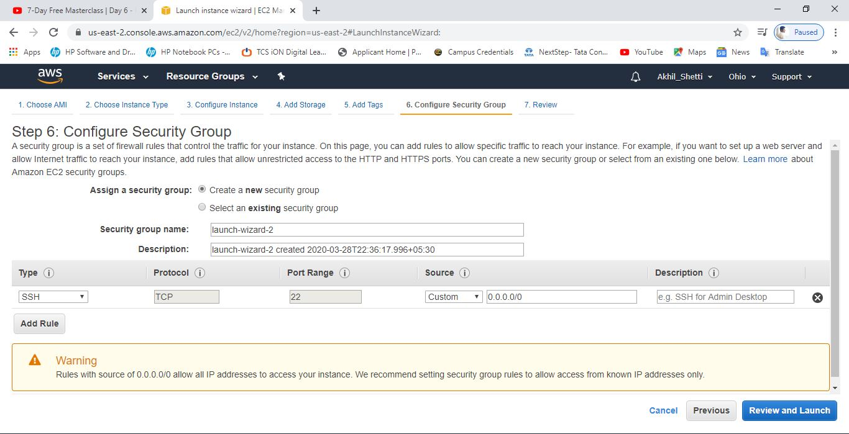

1. **Key pair download: (Screenshot was not taken at the time of creation since it was not mentioned earlier, so saved key’s ss is used)**

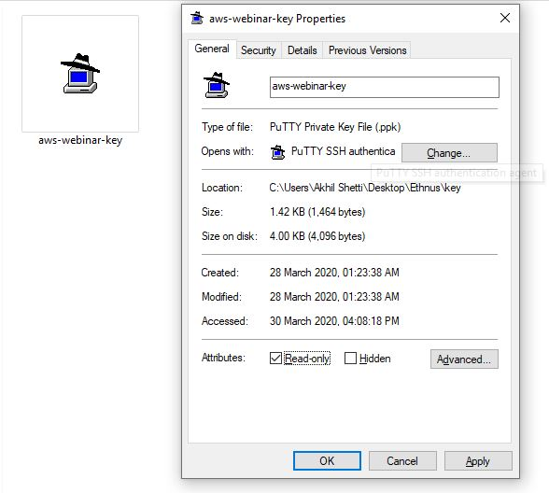

1. **PUTTYGEN Conversion:**

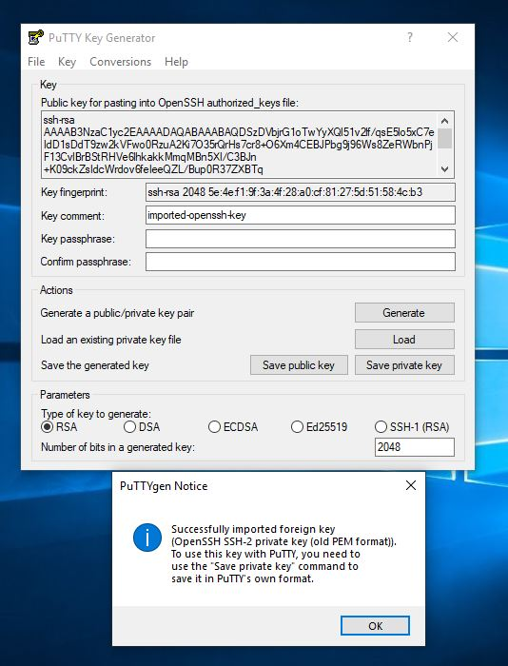

1. **Logged in Black Screen:**

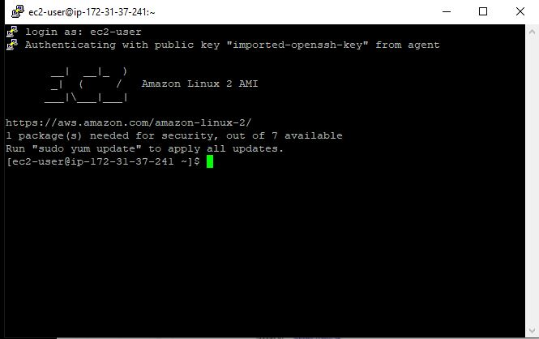

1. **S3:**
2. **Creating a bucket:**

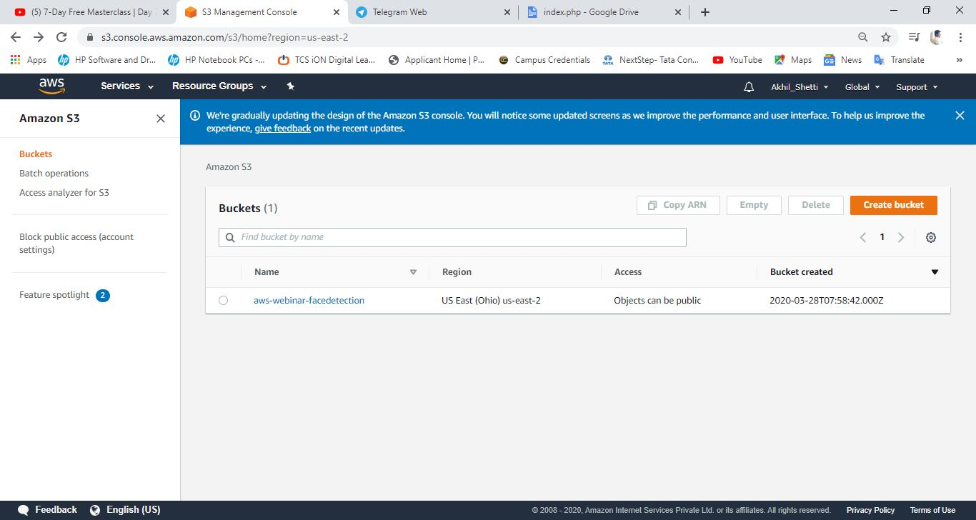

1. **Uploading an object:**

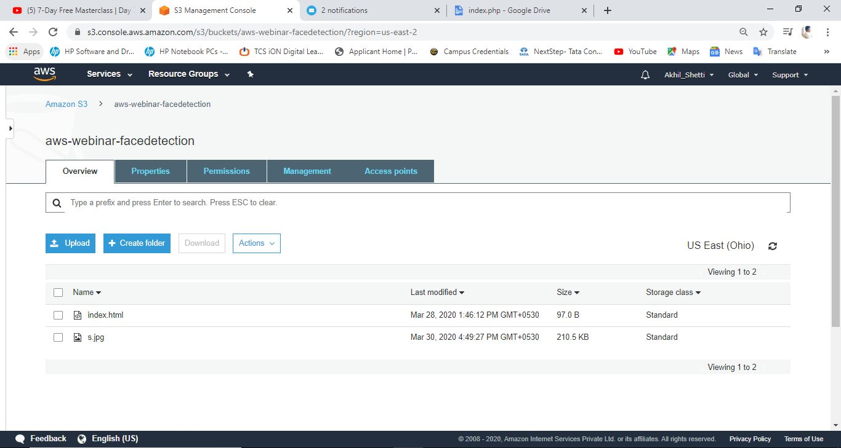

1. **Enabling static website:**

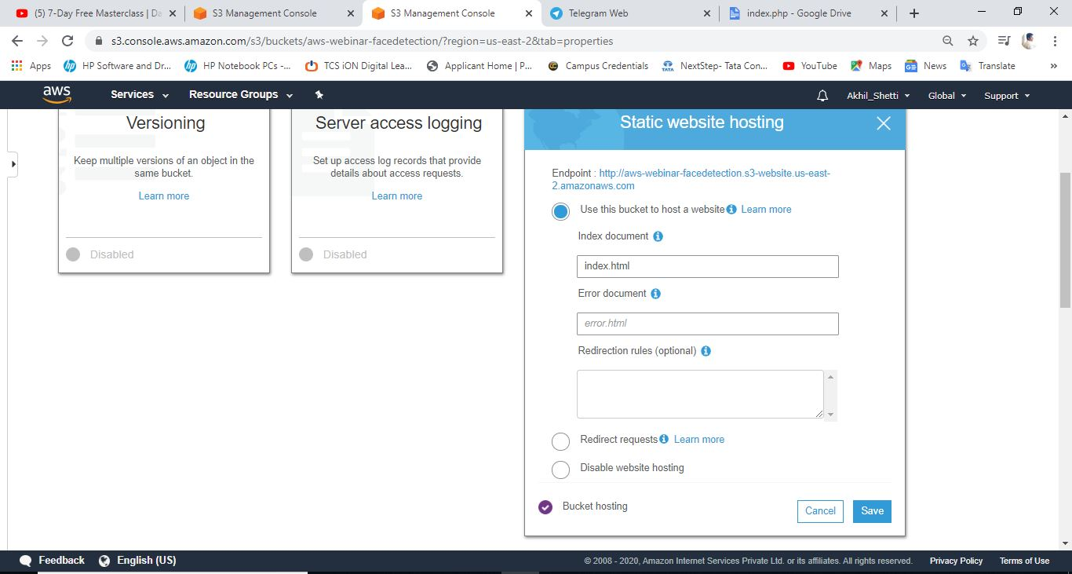

1. **Making the object public:**

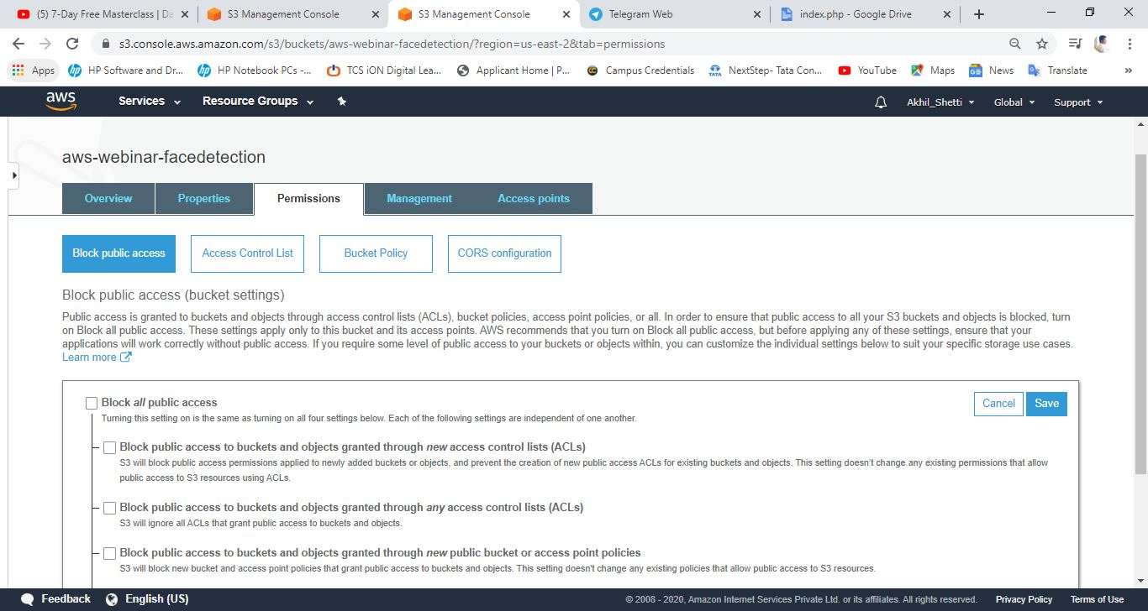

1. **Checking S3 link on browser:**

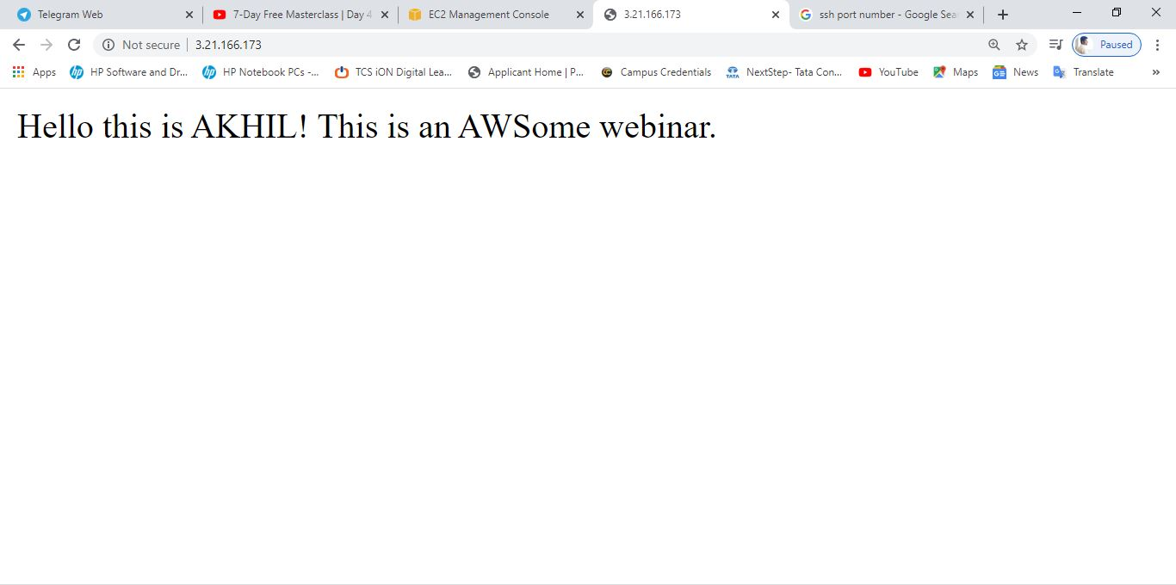

1. **Rekognition:**
2. **Face detect:**

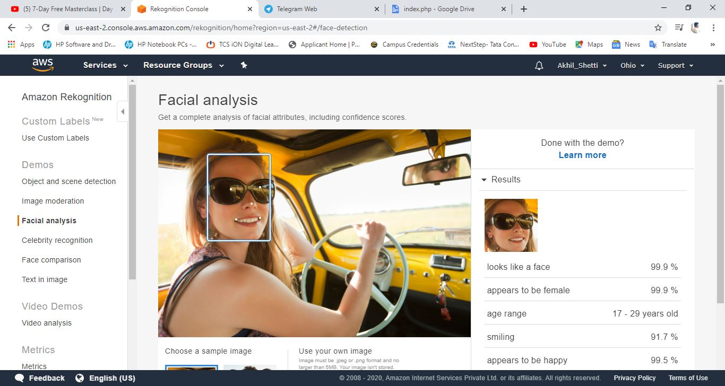

1. **Face Compare:**

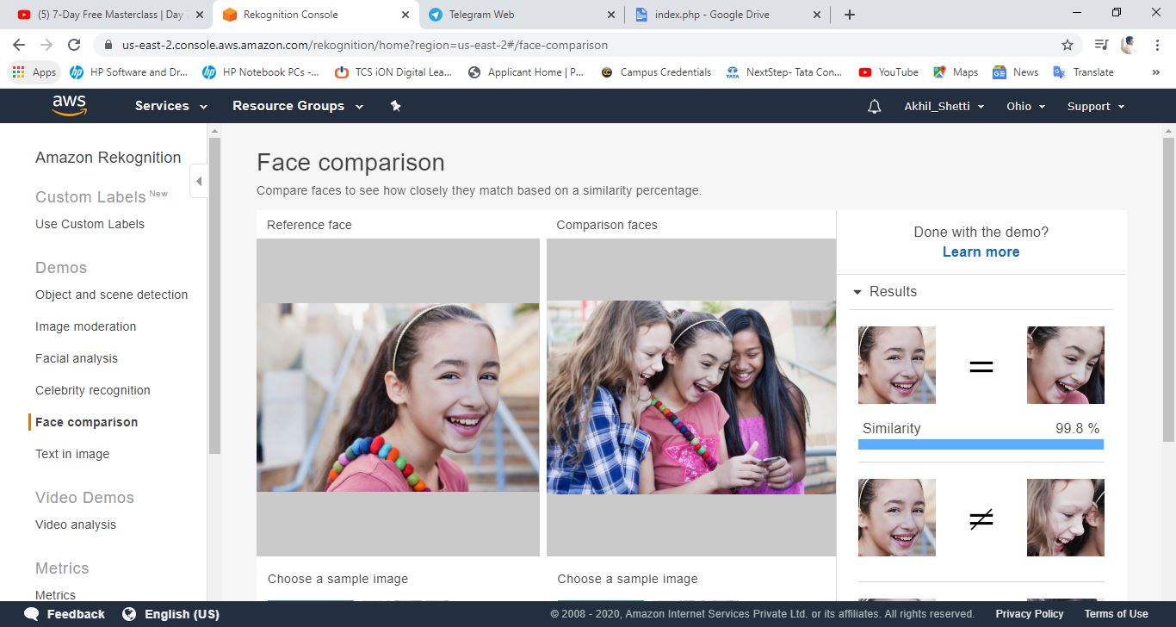

1. **Celebrity recognition:**

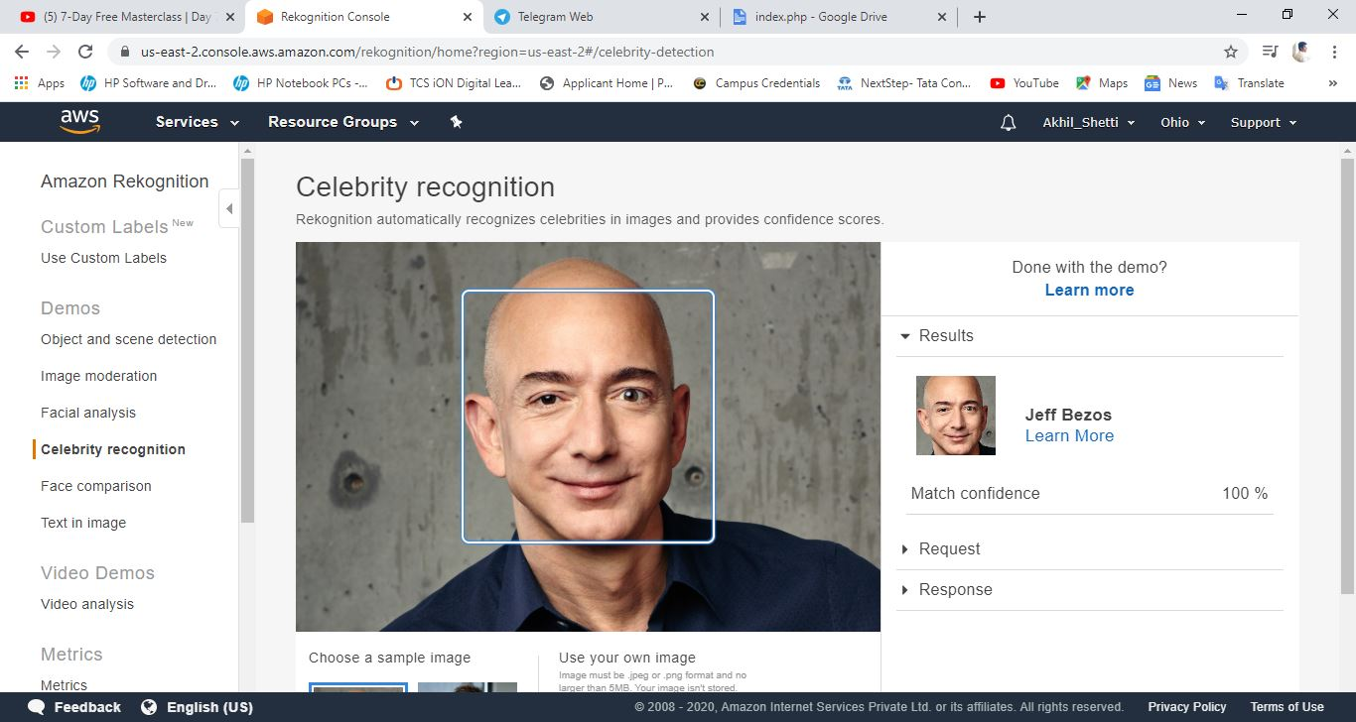

1. **Text in image:**

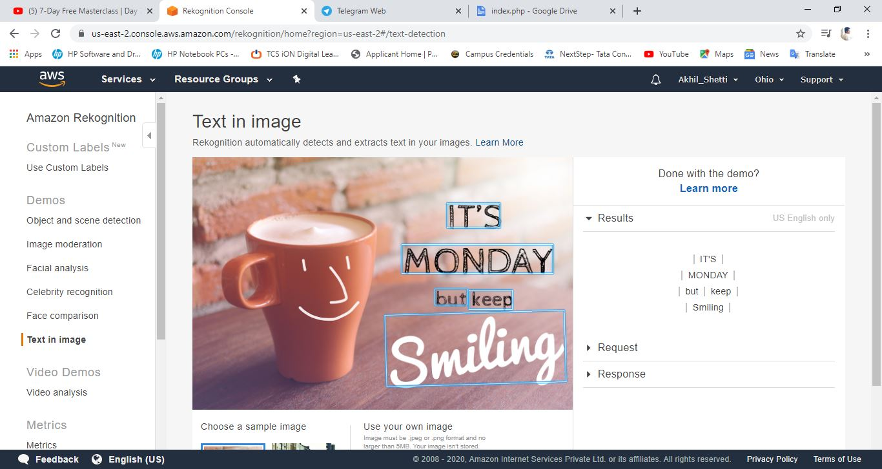

1. **EC2 & S3:**
2. **Installing aws-sdk:**

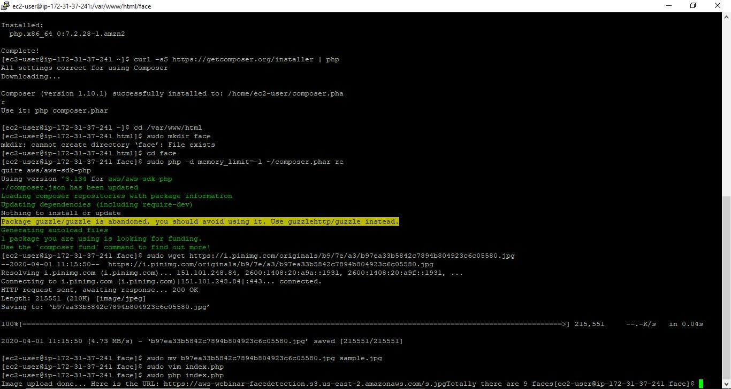

1. **Installing php:**

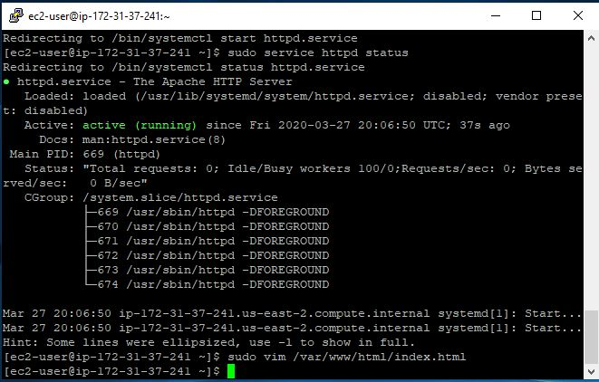

1. **Index.php Code:**

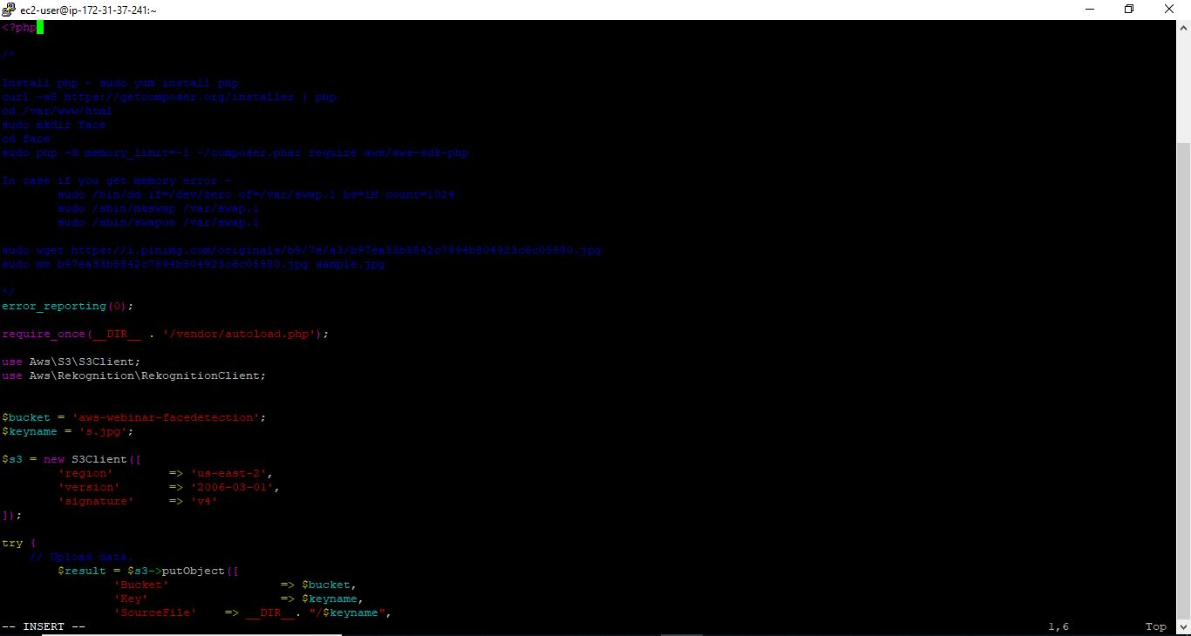

1. **Upload Success Screenshot:**

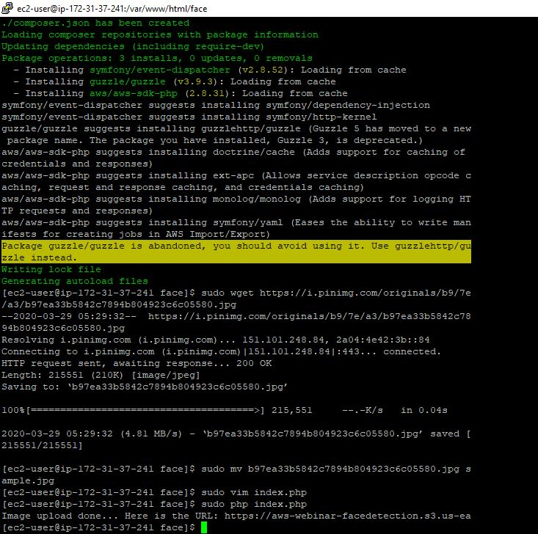

1. **EC2 & Rekognition:**
2. **Face Detect success screenshot :**

